

PRT661
DATA SCIENCE PRACTICE

ASSESSMENT 02
TECHNICAL DEVELOPMENT

FORECASTING ASSAULT RATES ACROSS NT REGIONS TO SUPPORT PUBLIC SAFETY RESOURCE PLANNING

Submitted by: Group DAN2 - THEME2
Lecturer: Dr Thuseethan Selvarajah

Student:
Thi Xuan Thanh Tran (Emma) - S389244
Ngoc Anh Nguyen (Will) - S386805
Van Hoi Dang (Hendrick) - S395598
Le Nhat Minh Tran (Thomas) - S390789

11 September 2026
￼￼
Table of Contents
1. Project overview and objectives 3
2. Theme justification 3
3. Problem statement 4
4. Initial architecture diagram 4
5. Workflow plan 7
6. Task allocation and team structure 8
7. Initial risk analysis 9
8. Ethics, privacy and security considerations 9
9. References 10

LIST OF TABLES
Table 1: Data sources 4
Table 2: Pipeline stages, tools and purpose 6
Table 3. Twelve-week workflow plan 7
Table 4. Task allocation and team structure 8

LIST OF FIGURES
Figure 1: Project Architecture 5

SECTION 1 – Assessment 1 Report
- Project overview and objectives
This project develops an end-to-end forecasting system for monthly, region level assault rates in the Northern Territory (NT), designed to strengthen operational planning within NT Police, Fire and Emergency Services (PFES). The work involves three core components:
- Building a secure and automated data pipeline covering acquisition, storage, and processing of NT crime datasets along with relevant datasets;
- Developing a robust forecasting model capable of producing interpretable, region-specific monthly predictions; and
- Delivering an interactive dashboard that presents historical trends, forecasts, and risk indicators for PFES operational use. The system ultimately supports PFES by improving resource allocation, enabling early identification of emerging hotspots, and enhancing evidence-based decision-making across the Territory.
The system supports PFES through better resource allocation, early hotspot identification, and evidence-based decision-making.
- Primary users: PFES operational planners and duty officers - shift commanders (patrol scheduling), regional operations managers (cross-station coordination), and strategic planning staff (quarterly staffing levels).
- Secondary users: PFES analysts needing historical trend data for budget/policy submissions.
The dashboard targets non-technical operational staff, prioritising clear visual summaries over raw statistical output.
- Theme justification
The project's core theme is forecasting monthly assault rates across NT regions, within the crime analysis domain. Forecasting suits this data because it is genuinely time-series: assault counts show month-to-month dependence, seasonal patterns (dry vs wet seasons), and temporal autocorrelation - requiring models that capture temporal structure rather than static methods.
This theme aligns with the five mandatory data-science capabilities:
- Acquisition: pulling data from the NTG open data portal (Northern Territory Government, 2026)
- Storage: secure, structured retention of historical records.
- Processing: cleaning, aggregation, and feature engineering into monthly, region-level series.
- Analytics: the forecasting model itself, capturing trends, seasonality, and uncertainty.
- Visualisation: an operational dashboard showing patterns, predictions, and regional risk signals.
Together, these form a complete end-to-end system supporting PFES's operational planning and decision-making.
This project goes beyond training a single model - it spans the full data science lifecycle:

- Data sourcing & reconciliation: integrating 3 heterogeneous public datasets with differing formats and update cycles
- Storage & cataloguing: designing a secure, structured layer for historical and incoming data
- Data engineering: handling structural breaks in crime-recording and inconsistent regional boundaries
- Domain & ethical judgement: addressing Indigenous data governance and predictive-policing misuse risks to shape model outputs
- End-to-end delivery: a user-facing dashboard, not just a model artifact
The forecasting model is just one component of this pipeline. This system-level scope is what distinguishes the project as data science rather than applied ML.
- Problem statement
PFES faces sustained resource pressure from high, volatile crime volumes across the NT. Monthly assault counts typically range 750 -1,100 incidents Territory-wide, with notable regional fluctuation (Northern Territory Government, 2026); demographic and alcohol-consumption factors may also contribute. These unpredictable surges strain PFES's finite staffing and patrol capacity (Northern Territory Police Association, 2025).
This volatility directly affects PFES's resource planning. Darwin, Alice Springs, Katherine, and Tennant Creek show distinct, shifting assault patterns, requiring frontline teams to adjust without advance warning. High domestic-violence involvement (often 60 - 70% of total assaults) and significant alcohol involvement further intensify demand on policing, investigations, and interagency coordination (Northern Territory Government, 2026). Without a mechanism to anticipate escalation, PFES remains reactive - reallocating resources only after spikes occur.
This project addresses that challenge with a forecasting system producing monthly, region-level assault predictions, backed by a secure data pipeline and dashboard. This gives PFES anticipatory visibility into hotspots and workload, enabling proactive staffing, patrol scheduling, and earlier interventions.
This aligns with PFES's intelligence-led approach, as seen in Operation Ventura (NTPFES, 2026), and extends it by helping PFES anticipate pressure points before they escalate - supporting more efficient resource use and sustained crime-reduction outcomes.
- Initial architecture diagram
Table 1: Data sources
Datasets | Publisher | Date published | URL | File format | Rows | Columns
Population estimates for NTG Service Regions (1986 to 2025) | Northern Territory Government | 07 March 2024 | https://data.nt.gov.au/dataset/nt-government-regions-1986-2025 | XLSX | 17,280 | 7
NT Crime Statistics 2020- 2023 | Northern Territory Government | 16 January 2024 | NT Crime Statistics November 2023 - Dataset - NTG Open Data Portal | CSV | 46037 | 10
NT Crime Statistics Latest | Northern Territory Government | 11 June 2026 | https://data.nt.gov.au/dataset/current-nt-crime-statistics-april-2026 | CSV | 9111 | 10
Wholesale Alcohol Supply by Quarter, 2023 | Department of Tourism and Hospitality | 13 November 2025 | https://data.nt.gov.au/dataset/wholesale-alcohol-supply-by-quarter-2023 | XLSX | 29 | 12
Wholesale Alcohol Supply by Quarter, 2024 |  |  | https://data.nt.gov.au/dataset/wholesale-alcohol-supply-by-quarter-2024 |  | 29 | 12
Wholesale Alcohol Supply by Quarter, 2025 |  |  | https://data.nt.gov.au/dataset/wholesale-alcohol-supply-by-quarter-2025 |  | 29 | 12

The NT Crime Statistics dataset was selected because it provides monthly time-series crime data by region and offence type, making it suitable for temporal and spatial trend analysis. NTG population data were used to standardise crime rates per 100,000 population, enabling fair comparisons across regions with different population sizes.

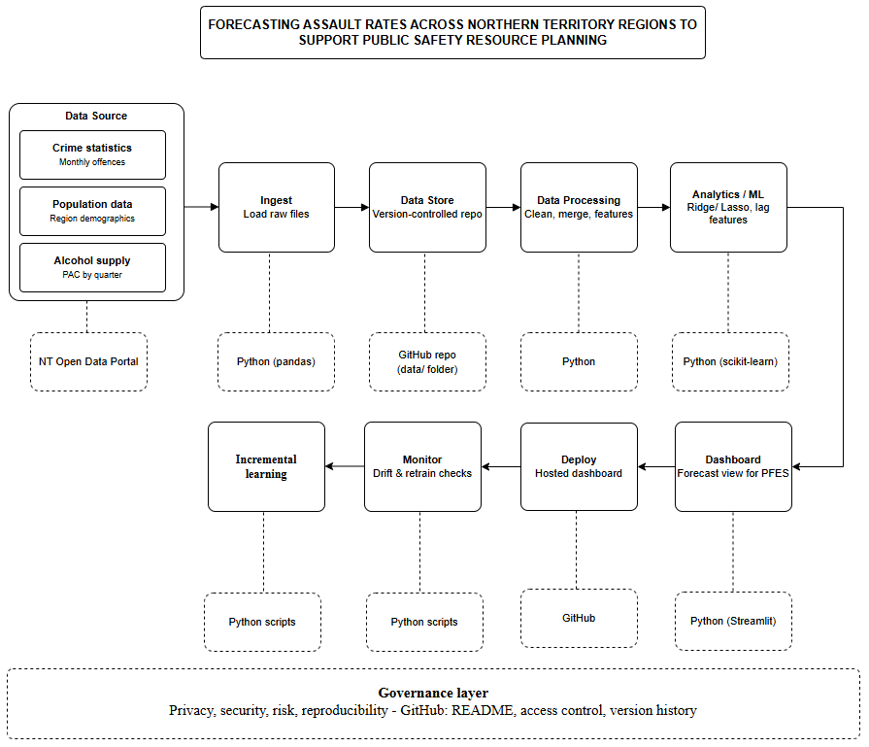
Figure 1: Project Architecture
Table 2: Pipeline stages, tools and purpose
Stage | Tool/ Technology | Purpose
Data Source | NT Open Data Portal | Three public datasets: crime statistics, population demographics, wholesale alcohol supply.
Ingest | Python (pandas) | Loads raw CSV/XLSX files from each source.
Data Store | GitHub repository | Version-controlled storage of raw and processed data, giving change history and access control in place of a cloud data lake.
Data Processing | Python (pandas) | Cleans, merges and engineers features (lagged indicators, cyclical month encoding, per-capita normalisation) across the three sources.
Analytics / ML | Python (scikit-learn) | Trains and validates Ridge and Lasso regression models to forecast monthly, region-level assault rates.
Dashboard | Python (Streamlit) | Presents forecasts and regional trends in an interactive view for PFES.
Deploy | Streamlit Community Cloud (via GitHub) | Automatically redeploys the live dashboard whenever changes are pushed to the GitHub repository.
Monitor | Python scripts | Checks forecast performance for drift and flags when the model should be retrained.
Incremental learning | Python scripts | Continuously adjusting the model parameters by training based on incoming data

Governance considerations spanning the full pipeline (privacy, security and reproducibility) are addressed through GitHub's built-in access controls, commit history and README documentation, and are detailed further in Section 8.
Although the architecture conceptually mirrors AWS's managed data pipeline pattern (S3 à Glue Data Catalog à Glue ETL à SageMaker à QuickSight, with SageMaker Model Monitor for post-deployment monitoring and SageMaker’s built-in incremental training capability for scheduled retraining), the group project implements each stage using open-source, non-AWS tools, consistent with the module's guidance to rely on open-source tools for the group deliverable.
Technology roadmap. The current implementation uses open-source tools (pandas, scikit-learn, and Streamlit with GitHub providing version-controlled storage) to deliver a working proof of concept within the semester timeframe. Should PFES adopt the system operationally, the architecture is designed to migrate directly onto AWS-equivalent managed services with minimal redesign: the GitHub-based data store to Amazon S3, pandas-based data processing to AWS Glue ETL, the Analytics/ML stage to Amazon SageMaker for managed training and scheduled deployment, the Streamlit dashboard to Amazon QuickSight, the Monitor stage to Amazon SageMaker Model Monitor, and the Incremental learning stage to SageMaker's built-in incremental (continuous) training capability. Future enhancements under consideration include real-time or near-real-time data ingestion (replacing manual/batch downloads) and integration with additional predictors such as weather or event-calendar data to improve forecast accuracy.
- Workflow plan
The workflow plan spans the full 12-week semester and is aligned to the four assessment milestones (Table 3). Weeks immediately preceding each submission are used for consolidation and reporting, other weeks are allocated to the team members responsible for the relevant pipeline stage, as shown in Table 4.
Table 3. Twelve-week workflow plan
Week | Focus | Deliverable | Owner
1 | Team formation, theme confirmation, environment setup. | GitHub repository with README; Streamlit account set up; draft problem statement | All
2 | Data collection and validation, architecture design | Architecture diagram; project management board populated; confirmed data sources | All
3 | Proposal writing and initial risk analysis | Assessment 1 submitted: Project proposal and design | All
4 | Load raw data into the repository; begin cleaning and harmonising six years of multi-source data; resolve region-mapping and data-regime discontinuities | Raw data in GitHub; cleaned, merged dataset in progress | Will (Ingest)  Emma (Data processing)
5 | Finalise ingest and storage structure in GitHub; complete data processing scripts; preliminary exploratory analysis | Working ingest/ store/ processing stages; EDA notebook | Will (Ingest, Data store)  Emma (Data processing)
6 | Consolidate pipeline evidence and baseline model into progress report | Assessment 2 submitted: Progress report and development | All
7 | Feature engineering: lagged indicators, cyclical encoding, per-capita normalisation | Feature set finalised for modelling | Hendrick (Analytics/ML)
8 | Model training and validation; begin dashboard build | Validated candidate model; dashboard prototype | Hendrick (Analytics/ML)  Thomas (Dashboard)
9 | Rehearse and deliver technical demonstration | Assessment 3 submitted: Group Technical demonstration and presentation | All
10 | Incorporate feedback; finalise dashboard; deploy to Streamlit Community Cloud; implement monitoring and retraining logic | Deployed dashboard; monitoring stage implemented | Thomas (Dashboard, Deploy)  Emma (Monitor)
11 | End-to-end pipeline testing; draft final report sections | Full pipeline validated; report draft | All
12 | Final review and submission | Assessment 4 submitted: Final Professional Report | All
- Task allocation and team structure
Each team member owns one or two pipeline stages for the duration of the semester (Table 4), ensuring individually attributable contributions are visible in the GitHub commit history across all four assessments.
Table 4. Task allocation and team structure
Member | Primary role | Responsibilities
Will Nguyen | Ingest & Data Store | Loads the three raw datasets and maintains the version-controlled GitHub repository structure (raw and processed data folders)
Emma Tran | Data processing & Monitor | Cleans, merges and engineers features across the three data sources; implements post-deployment drift-checking scripts
Hendrick Dang | Analytics / ML | Develops, tunes and validates the Ridge/Lasso forecasting model
Thomas Tran | Dashboard & Deploy | Builds the Streamlit dashboard and manages its deployment and redeployment via Streamlit Community Cloud.
- Initial risk analysis
The project has six main risks. These risks will be reviewed during each assessment milestone and updated when needed.
The first risk is changes in the crime data. The transition from PROMIS to SerPro in November 2023 and the ANZSOC classification transition in April 2025 may pose challenges in comparing old and new crime data. To minimise this risk, both transitions will be incorporated into the model.
The second one is that recent crime data may be incomplete because some offences are recorded later. To prevent incorrect results, the latest six months of data will not be included in the model’s training and testing.
The third risk is limited data on alcohol supply. This data is only available quarterly and may not cover enough years. The team will collect older data where possible. However, the main forecasting model will still work without alcohol data.
The fourth risk is the same region may be named or bounded differently in different datasets. This can lead to wrong data matching. The team will work with one shared set of regions and validate the data after each merge.
The fifth is a delay in dashboard deployment. To reduce this risk, the team will create and deploy a simple version of the dashboard early on, then improve it throughout the project.
And the final risk is misuse or misinterpretation of the forecasts. If predictions are read as statements about particular communities, the system could cause harm rather than support safety. Small counts in low-population regions could also make incidents identifiable. Forecasts will therefore be shown only at region and month level, with uncertainty ranges, and small values will be suppressed.
- Ethics, privacy and security considerations
Data privacy
The project only uses public and aggregated data from the Northern Territory Government and the Australian Bureau of Statistics. It does not use personal information or individual records. However, very small crime counts may still make some incidents easier to identify. Small values will therefore be hidden or grouped before being shown on the dashboard.
Indigenous data governance
Aboriginal people are strongly represented in NT crime statistics (Northern Territory Police Force, 2025), so the data must be used carefully and respectfully. The project follows the CARE Principles (Carroll et al., 2020) and the AIATSIS Code of Ethics (AIATSIS, 2020). The model will only make predictions at the regional and monthly level and will not make predictions based on Indigenous status.
Responsible use
The system is designed to help PFES plan staff and resources. It is not designed to predict whether an individual will commit a crime or to target specific addresses or communities.
Forecasts may not always be correct, so the dashboard will show uncertainty and explain the limitations of the data and model. This helps users avoid treating the predictions as exact results.
Security and reproducibility
Only public data and project code will be stored in the GitHub repository. Passwords, API keys and private information will not be uploaded.
The project will also keep its data-processing and analysis steps in version-controlled code. This allows others to understand, replicate, and verify the results.
GitHub repository:
https://github.com/HendrickDang/PRT661-DATA-SCIENCE-PRACTICE

Project management board (JIRA): https://hendrickdang.atlassian.net/jira/software/projects/SCRUM/boards/1

- References
Australian Bureau of Statistics. (2025, June). National, state and territory population. https://www.abs.gov.au/statistics/people/population/national-state-and-territory-population/latest-release.
Australian Bureau of Statistics. (2025). Prisoners in Australia. ABS. https://www.abs.gov.au/statistics/people/crime-and-justice/prisoners-australia/latest-release.
Australian Institute of Aboriginal and Torres Strait Islander Studies. (2020). AIATSIS Code of Ethics for Aboriginal and Torres Strait Islander Research. AIATSIS. https://aiatsis.gov.au/research/ethical-research/code-ethics
Carroll, S. R., Garba, I., Figueroa-Rodríguez, O. L., Holbrook, J., Lovett, R., Materechera, S., Parsons, M., Raseroka, K., Rodriguez-Lonebear, D., Rowe, R., Sara, R., Walker, J. D., Anderson, J., & Hudson, M. (2020). The CARE Principles for Indigenous Data Governance. Data Science Journal, 19(1), 1–12. https://doi.org/10.5334/dsj-2020-043
Hathaway-Wilson, J. (2025, September 21). NT police data shows violent crime increasing, property crime decreasing. Abc.net.au; ABC News. https://www.abc.net.au/news/2025-09-22/is-nt-crime-decreasing-since-clp-government-elected-police-data/105797920
Northern Territory Government. (2026). NT crime statistics march 2026 - NTG open data portal. Nt.Gov.Au. https://data.nt.gov.au/dataset/current-nt-crime-statistics-march-2026
Northern Territory Police Association. (2025). Northern Territory Police Association demands better pay and conditions to prevent officer exodus. In Ntpa.com.au. https://www.ntpa.com.au/knowledgebase/article/KA-01198/
NTPFES. (2026). Operation ventura | NT police, fire & emergency services. NT Police, Fire & Emergency Services. https://pfes.nt.gov.au/newsroom/2026/operation-ventura
Northern Territory Police Force. (2025). Annual Report 2024-25. https://hdl.handle.net/10070/1016397.

SECTION 2 – Project Update Summary
Immediately following the Assessment 1 report, include a one-page Project Update Summary describing the project's progress since Assessment 1.
The summary should clearly identify:
• Changes Since Previous Assessment
Area | Previous State | Current State | Justification
• Contribution Summary
Team Member | Contribution
Thi Xuan Thanh Tran (Emma)
Ngoc Anh Nguyen (Will)
Van Hoi Dang (Hendrick)
Le Nhat Minh Tran (Thomas) | Review the pipeline, making suggestions and implement changes when necessary
• Evidence Locations
Evidence | Repository Location

SECTION 3 – Assessment 2 Technical Development
      - Project overview and objectives
This project develops an end-to-end forecasting system for monthly, region level assault rates in the Northern Territory (NT), designed to strengthen operational planning within NT Police, Fire and Emergency Services (PFES). The work involves three core components:
- Building a secure and automated data pipeline covering acquisition, storage, and processing of NT crime datasets along with relevant datasets;
- Developing a robust forecasting model capable of producing interpretable, region-specific monthly predictions; and
- Delivering an interactive dashboard that presents historical trends, forecasts, and risk indicators for PFES operational use. The system ultimately supports PFES by improving resource allocation, enabling early identification of emerging hotspots, and enhancing evidence-based decision-making across the Territory.
The system supports PFES through better resource allocation, early hotspot identification, and evidence-based decision-making.
- Primary users: PFES operational planners and duty officers - shift commanders (patrol scheduling), regional operations managers (cross-station coordination), and strategic planning staff (quarterly staffing levels).
- Secondary users: PFES analysts needing historical trend data for budget/policy submissions.
The dashboard targets non-technical operational staff, prioritising clear visual summaries over raw statistical output.
- Theme justification
The project's core theme is forecasting monthly assault rates across NT regions, within the crime analysis domain. Forecasting suits this data because it is genuinely time-series: assault counts show month-to-month dependence, seasonal patterns (dry vs wet seasons), and temporal autocorrelation - requiring models that capture temporal structure rather than static methods.
This theme aligns with the five mandatory data-science capabilities:
- Acquisition: pulling data from the NTG open data portal (Northern Territory Government, 2026)
- Storage: secure, structured retention of historical records.
- Processing: cleaning, aggregation, and feature engineering into monthly, region-level series.
- Analytics: the forecasting model itself, capturing trends, seasonality, and uncertainty.
- Visualisation: an operational dashboard showing patterns, predictions, and regional risk signals.
Together, these form a complete end-to-end system supporting PFES's operational planning and decision-making.
This project goes beyond training a single model - it spans the full data science lifecycle:

- Data sourcing & reconciliation: integrating 3 heterogeneous public datasets with differing formats and update cycles
- Storage & cataloguing: designing a secure, structured layer for historical and incoming data
- Data engineering: handling structural breaks in crime-recording and inconsistent regional boundaries
- Domain & ethical judgement: addressing Indigenous data governance and predictive-policing misuse risks to shape model outputs
- End-to-end delivery: a user-facing dashboard, not just a model artifact
The forecasting model is just one component of this pipeline. This system-level scope is what distinguishes the project as data science rather than applied ML.
- Problem statement
PFES faces sustained resource pressure from high, volatile crime volumes across the NT. Monthly assault counts typically range 750 -1,100 incidents Territory-wide, with notable regional fluctuation (Northern Territory Government, 2026); demographic and alcohol-consumption factors may also contribute. These unpredictable surges strain PFES's finite staffing and patrol capacity (Northern Territory Police Association, 2025).
This volatility directly affects PFES's resource planning. Darwin, Alice Springs, Katherine, and Tennant Creek show distinct, shifting assault patterns, requiring frontline teams to adjust without advance warning. High domestic-violence involvement (often 60 - 70% of total assaults) and significant alcohol involvement further intensify demand on policing, investigations, and interagency coordination (Northern Territory Government, 2026). Without a mechanism to anticipate escalation, PFES remains reactive - reallocating resources only after spikes occur.
This project addresses that challenge with a forecasting system producing monthly, region-level assault predictions, backed by a secure data pipeline and dashboard. This gives PFES anticipatory visibility into hotspots and workload, enabling proactive staffing, patrol scheduling, and earlier interventions.
This aligns with PFES's intelligence-led approach, as seen in Operation Ventura (NTPFES, 2026), and extends it by helping PFES anticipate pressure points before they escalate - supporting more efficient resource use and sustained crime-reduction outcomes.
- System Architecture
  - Data sources

Three datasets from distinct NT Government sources were integrated.
Table 1: Data sources
Datasets | Publisher | Date published | URL | File format | Rows | Columns
Population estimates for NTG Service Regions (1986 to 2025) | Northern Territory Government | 07 March 2024 | https://data.nt.gov.au/dataset/nt-government-regions-1986-2025 | XLSX | 17,280 | 7
NT Crime Statistics 2020- 2023 | Northern Territory Government | 16 January 2024 | NT Crime Statistics November 2023 - Dataset - NTG Open Data Portal | CSV | 46037 | 10
NT Crime Statistics Latest | Northern Territory Government | 11 June 2026 | https://data.nt.gov.au/dataset/current-nt-crime-statistics-april-2026 | CSV | 9111 | 10
Wholesale Alcohol Supply by Quarter, 2023 | Department of Tourism and Hospitality | 13 November 2025 | https://data.nt.gov.au/dataset/wholesale-alcohol-supply-by-quarter-2023 | XLSX | 29 | 12
Wholesale Alcohol Supply by Quarter, 2024 |  |  | https://data.nt.gov.au/dataset/wholesale-alcohol-supply-by-quarter-2024 |  | 29 | 12
Wholesale Alcohol Supply by Quarter, 2025 |  |  | https://data.nt.gov.au/dataset/wholesale-alcohol-supply-by-quarter-2025 |  | 29 | 12
Justification for each source:
- NT Crime Statistics: provides monthly time-series crime data by region and offence type, making it suitable for temporal and spatial trend analysis.
- NTG population data: to standardise crime rates per 100,000 population, enabling fair comparisons across regions with different population sizes.
- Wholesale Alcohol Supply: justified by the established criminological link between alcohol availability and violent crime.
  - Project Architecture


Figure 1: Project Architecture
Table 2: Pipeline stages, tools and purpose
Stage | Tool/ Technology | Purpose
Data Source | NT Open Data Portal | Three public datasets: crime statistics, population demographics, wholesale alcohol supply.
Ingest | Python (pandas) | Loads raw CSV/XLSX files from each source.
Data Store | GitHub repository | Version-controlled storage of raw and processed data, giving change history and access control in place of a cloud data lake.
Data Processing | Python (pandas) | Cleans, merges and engineers features (lagged indicators, cyclical month encoding, per-capita normalisation) across the three sources.
Analytics / ML | Python (scikit-learn) | Trains and validates Ridge and Lasso regression models to forecast monthly, region-level assault rates.
Dashboard | Python (Streamlit) | Presents forecasts and regional trends in an interactive view for PFES.
Deploy | Streamlit Community Cloud (via GitHub) | Automatically redeploys the live dashboard whenever changes are pushed to the GitHub repository.
Monitor | Python scripts | Checks forecast performance for drift and flags when the model should be retrained.
Incremental learning | Python scripts | Continuously adjusting the model parameters by training based on incoming data
Governance considerations spanning the full pipeline (privacy, security and reproducibility) are addressed through GitHub's built-in access controls, commit history and README documentation, and are detailed further in Section 8.
Although the architecture conceptually mirrors AWS's managed data pipeline pattern (S3 à Glue Data Catalog à Glue ETL à SageMaker à QuickSight, with SageMaker Model Monitor for post-deployment monitoring and SageMaker’s built-in incremental training capability for scheduled retraining), the group project implements each stage using open-source, non-AWS tools, consistent with the module's guidance to rely on open-source tools for the group deliverable.
Technology roadmap. The current implementation uses open-source tools (pandas, scikit-learn, and Streamlit with GitHub providing version-controlled storage) to deliver a working proof of concept within the semester timeframe. Should PFES adopt the system operationally, the architecture is designed to migrate directly onto AWS-equivalent managed services with minimal redesign: the GitHub-based data store to Amazon S3, pandas-based data processing to AWS Glue ETL, the Analytics/ML stage to Amazon SageMaker for managed training and scheduled deployment, the Streamlit dashboard to Amazon QuickSight, the Monitor stage to Amazon SageMaker Model Monitor, and the Incremental learning stage to SageMaker's built-in incremental (continuous) training capability. Future enhancements under consideration include real-time or near-real-time data ingestion (replacing manual/batch downloads) and integration with additional predictors such as weather or event-calendar data to improve forecast accuracy.
- Data cleaning and preprocessing – Emma

Before any analysis can begin, the datasets need to be cleaned and standardised so they can be combined reliably. Three main problems had to be solved:
- The crime data switched to a new classification system mid-way through the study period.
- The geographic regions used in the crime files do not match those in the population files, and
- Certain flags in the crime records needed to be encoded correctly to remain consistent across both file formats.

Step 1: Crime Data Cleaning

The two crime files use different offence category labels. The table below lists all translations:
Old category (nt_crime_statistics_2020-2023.csv) | à | New category (nt_crime_statistics_latest.csv)
Acts intended to cause Injury | à | 02 Assault
Homicide and related Offences | à | 01 Homicide
Abduction - harassment and other offences against the person | à | 04 Harm or endanger persons
Other dangerous or negligent acts endangering persons | à | 04 Harm or endanger persons
Sexual assault and related offences | à | 03 Sexual offences
Robbery, extortion and related offences | à | 05 Robbery, blackmail, and extortion
House break-ins | à | 061 Burglary – dwelling
Motor vehicle theft and related offences | à | 07 Theft
Theft and related offences (other than MV) | à | 07 Theft
Property Damage Offences | à | 11 Property damage offences

November 2023 gap. November 2023 is absent from both crime files. It is retained as NaN and never imputed.

Binary encoding. ‘Alcohol involvement’ and ‘DV involvement’ flags are encoded as 0/1. The dash (-) is treated as 0. Critically, the flags are multiplied by ‘Number of offences’ rather than counting source rows:

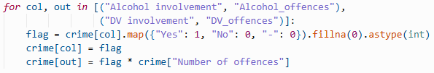

Step 2: Region Remapping

Crime data uses 7 NT Police reporting regions; population and alcohol data use the 6 NT Government (NTG) statistics regions. Using mismatched boundaries without correction would assign the entire Greater Darwin population to both Darwin and Palmerston separately, doubling the denominator and producing per-capita rates roughly half their true value. All crime rows are remapped in two stages.
- Stage 1 – Direct mapping:
- Darwin + Palmerston à Greater Darwin
- Alice Springs à Central Australia
- Katherine à Big Rivers
- Nhulunbuy à East Arnhem
- Tennant Creek à Barkly
- Unknown à Top End
- Stage 2 – SA2-level mapping for NT Balance rows.

NT Balance records carry no town identifier. Each row also has a Statistical Area 2 (SA2) field indicating the sub-region of the offence. A secondary lookup table (SA2_TO_REGION) maps 16 SA2 values to their parent NTG region, such as:
- SA2 = ‘Barkly’ à Barkly
- SA2 = ‘East Arnhem’ à East Arnhem
- SA2 = ‘Howard Springs’ à Greater Darwin
- Any unrecognised SA2 à Top End

Step 3: Population Data Cleaning

The population file has a 'Status' column ('Preliminary' / 'Final'). If a year had both statuses, summing across demographic breakdowns would double-count residents. The pipeline validates this before aggregation:

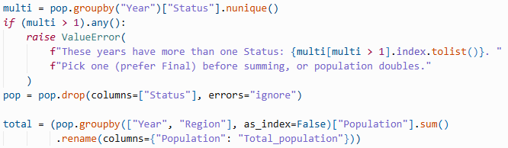

Population summed across all demographic breakdowns for each Region x Year combination. Status column dropped after validation.

Data trimmed to the 2015-2025 analysis window à 66 rows (6 regions x 11 years).
- Data engineering – Will

Data engineering transforms the three cleaned source tables into a single analysis-ready panel. Five steps handle dataset merging, per-capita normalisation, lag feature construction, age-structure dimensionality reduction, and train/test partitioning.
  - Merging the Three Source Tables

Two left joins produce the merged panel. Crime rows carry Year, Quarter, and Region keys; alcohol joins on Year × Quarter × Region; population joins on Year × Region.

  - Per-Capita Metrics
  - Features Engineering
A series of new features have been constructed from existing features to capture a holistic view of the crime situation in the Northern Territory. The features and reasons behind them are demonstrated below

Log_assault_rate:
Since the crime rate is not normally distributed but rather follows a log-normal distribution (heavily right-skewed) due to seasonality characteristics. By transforming the assault rate logarithmically, we aim to stabilise the distribution, making it symmetrical which is essential for good performance of linear regression models(Limpert et al., 2001)
Sin_month and cos_month:
To preserve the cyclic behaviours of months, sine and cosine functions are applied to represent time since these trigonometric functions pursue cycles between “top” and “bottom” and have a settled cycle length which is perfect for modelling regular cycles such as months (Lindsey and Pavur, 2005)

Season:
This feature serves as an indicator for wet and dry seasons, which according to research by Blakeslee et al. (2018), have a statistically significant relationship with crime incidence.
is_new_year:
According to research by Baird et al. , (2019), the homicide rate experiences a significant spike on New Year’s Day. Therefore, this feature is added to capture this valuable information.

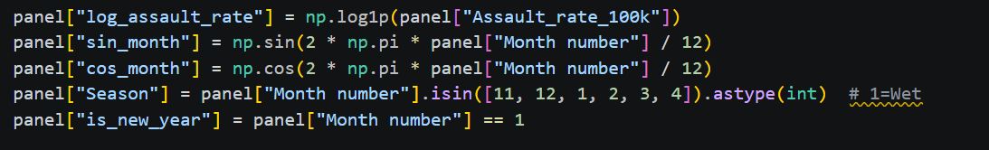

  - Train/Test Split
Because of the nature of time-series data, results are susceptible to previous information. The dataset needs to be split into train and test using a temporal cut-off, ensuring that training data only contains observations prior to the test period to avoid any leakage of future information (Hasanov et al., 2022).
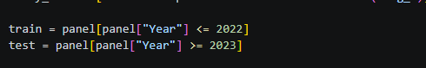
- Analytics and machine learning – Hendrick
  - Exploratory Data Analysis (EDA)

EDA serves as an important step after data ingestion and pre-processing by enabling the inspection of data for distribution, outliers and anomalies (Komorowski et al., 2016). Furthermore, EDA guides and informs effective feature engineering (Mao, 2015), an important step in this pipeline to ensure meaningful patterns are captured.
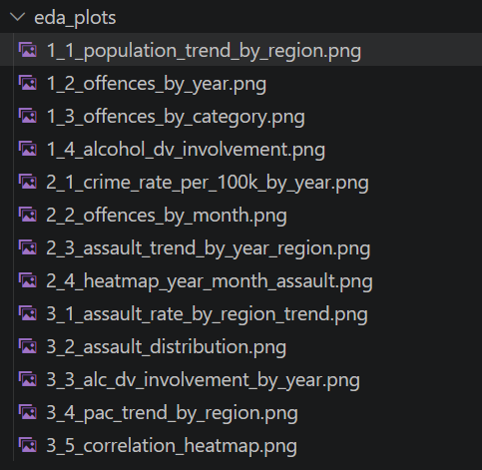
  - PCA of regional Age Structure

Applying PCA to the regional age structure allows the compression of data size, leading to a more efficient and quicker model training while keeping most of the information from the data (Mishra et al., 2017)
  - Feature Variant Selection
Our strategy to capture the best combination of features through testing them on a linear regression model and determine the winner by comparing their Root Mean Square Error (RMSE)
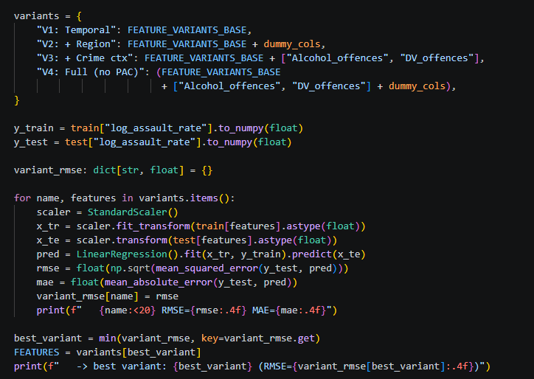
  - Multicollinearity Check and Hyperparameter Tuning
With an aim to maximise the model performance, a multicollinearity check was carried out by calculating the Variance Inflation Factor (VIF) of each feature and removing the ones with VIF > 30. High multicollinear features are known to have a negative effect on the regression model by hampering the interpretability of model predictors and resulting in highly volatile coefficient estimates (Dertli et al., 2024).
Another approach to optimising model performance is hyperparameter tuning. In this pipeline, tuning for linear models (Ridge and Lasso) is performed using alpha tuning with is to choose the most favourable alpha parameter that minimises the models' error in cross-validation (Deb, 2025)
  - Model Results and Evaluation
Analytics and Machine Learning
This subsection documents the forecasting and evaluation work completed since Assessment 1. It responds directly to the Assessment 1 feedback, which asked the team to justify the choice of Ridge and Lasso, compare them against suitable baselines, and define the forecast horizon, validation approach, evaluation metrics, uncertainty calculation, leakage-control strategy, drift thresholds and retraining rules. Each is addressed below. The work is implemented in evaluation.py in the repository root, which runs independently of the main pipeline and writes its results to Outputs/.
Forecast task definition
Assessment 1 described the objective as monthly, region-level assault forecasting over a three-to-twelve month horizon but did not specify the prediction task precisely. It is now defined as follows.
- Target: assault offences per 100,000 residents, by NT Government service region, by calendar month. The model is fitted on the log1p transform of this rate and predictions are back-transformed before evaluation, so all reported errors are on the interpretable rate scale.
- Granularity: six regions (Barkly, Big Rivers, Central Australia, East Arnhem, Greater Darwin, Top End) across 116 months, giving 696 usable region-month observations after lag warm-up.
- Horizons: forecasts are produced and evaluated at 1, 3, 6 and 12 months ahead, spanning the operational range stated in Assessment 1.
- Evaluation window: the six most recent months are excluded because offences are still being recorded against them. This aligns the implementation with the commitment made in the Assessment 1 risk analysis.
Model selection and justification
Regularised linear regression is appropriate here for three reasons. First, the predictor set is dominated by lagged values of the target at one, three and twelve months, which are strongly correlated with one another; L2 regularisation is designed for exactly this collinearity, and Lasso additionally performs variable selection among competing lags. Second, the panel contains 696 observations across six regions, which is small for high-variance learners and creates a substantial overfitting risk. Third, the end user is an operational planner rather than a data scientist, and linear coefficients can be read directly as the effect of a change in each predictor, supporting the interpretability requirement identified in Assessment 1.
Validation design and leakage control
Two sources of information leakage were identified in the existing pipeline and corrected. First, the feature-variant comparison selected the best variant using error measured on the 2023 to 2025 test set, and the final models were then scored on that same set. Reported performance was therefore optimistic, because the test data had already influenced a modelling decision. Variant selection now takes place on cross-validation folds drawn only from the training period. Second, the cross-validation routine fitted the feature scaler on the entire frame before splitting, so each fold was standardised using statistics that included later folds. Scaling is now performed inside a scikit-learn Pipeline, which refits the scaler on each fold’s training rows alone.
Validation uses rolling-origin backtesting with an expanding window. At each origin the model is refitted on every month strictly earlier than that origin and then asked to predict the month h steps ahead. All predictors are lagged values or deterministic calendar terms, so no information from the target month or later enters the prediction. This measures forecasting performance rather than in-sample fit, and produces a distribution of errors across many origins rather than a single train-test split.
Baseline comparison
Assessment 1 compared candidate models only against one another, which cannot establish whether any of them add value. Two naive benchmarks were introduced: a seasonal naive forecast, which predicts the same month in the previous year, and a twelve-month moving average of the most recent complete year. Skill is reported as the percentage reduction in RMSE relative to the seasonal naive benchmark, so a negative value indicates a model performing worse than assuming last year repeats.
Table X. Forecast accuracy by horizon, assault rate per 100,000 (rolling-origin backtest)
Model | Horizon (months) | MAE | RMSE | MAPE (%) | Skill (%)
Moving average (12m) | 1 | 70.7 | 96.6 | 14.5 | 25.2
Ridge | 1 | 74.9 | 99.4 | 16.2 | 23.0
Linear | 1 | 75.1 | 99.4 | 16.2 | 23.0
Lasso | 1 | 78.8 | 120.6 | 15.7 | 6.6
Seasonal naive | 1 | 91.7 | 129.1 | 19.2 | 0.0
Moving average (12m) | 3 | 74.7 | 104.5 | 15.0 | 24.4
Ridge | 3 | 87.8 | 122.6 | 18.1 | 11.4
Lasso | 3 | 84.6 | 131.3 | 17.0 | 5.0
Seasonal naive | 3 | 95.6 | 138.3 | 19.5 | 0.0
Moving average (12m) | 6 | 76.1 | 105.7 | 15.2 | 25.0
Ridge | 6 | 87.8 | 123.4 | 18.0 | 12.5
Seasonal naive | 6 | 97.4 | 141.0 | 19.7 | 0.0
Moving average (12m) | 12 | 79.7 | 110.5 | 15.2 | 21.0
Ridge | 12 | 97.4 | 132.6 | 19.2 | 5.1
Seasonal naive | 12 | 96.2 | 139.8 | 19.2 | 0.0
Lasso | 12 | 97.8 | 153.2 | 18.8 | -9.6
Skill (%) is the RMSE reduction relative to the seasonal naive benchmark. Best model at each horizon shown in bold.
Interpretation of results
The twelve-month moving average outperforms every fitted model at every horizon tested. It achieves a 25.2 per cent RMSE improvement over the seasonal naive benchmark at one month and retains 21.0 per cent at twelve months, while the best regression model, Ridge, reaches 23.0 per cent at one month but falls to 5.1 per cent at twelve. Lasso performs worse than the seasonal naive benchmark at the twelve-month horizon, with a skill score of -9.6 per cent.
This is reported as a finding rather than a failure. It indicates that regional assault rates in the Northern Territory are dominated by a slow-moving local level, and that the month-to-month and seasonal structure the regression models attempt to capture contributes little additional predictive information at this level of aggregation. Three factors plausibly contribute: the panel is short relative to the number of parameters; the series contains two documented administrative breaks; and aggregating to six large regions smooths much of the local variation a richer model could exploit.
The practical implication is that the moving average should be adopted as the operational reference forecast, and that any model retained in the final system must demonstrate skill against it rather than against the seasonal naive benchmark alone. This is a stricter and more honest standard than the one applied in Assessment 1.
Uncertainty quantification
Prediction intervals are constructed empirically from the distribution of backtest residuals rather than from a parametric assumption, since the residuals are not normally distributed. For each horizon the tenth and ninetieth percentiles of the residual distribution are added to the point forecast. Empirical coverage of the resulting intervals is between 78 and 80 per cent against a nominal 80 per cent, indicating the intervals are well calibrated. The intervals are wide, spanning roughly 230 to 246 assaults per 100,000, which is itself an important operational message: forecasts at this granularity carry substantial uncertainty and should be presented to PFES as planning ranges rather than point predictions.
Structural breaks
Binary indicators were added for the two documented changes in crime recording: the transition from PROMIS to SerPro from December 2023, and the ANZSOC reclassification from April 2025. Including these indicators did not change cross-validation error, because the cross-validation period ends in 2022 and both indicators are therefore constant across every fold. They are retained because they are active in the evaluation period and because omitting a known level shift would bias the coefficients on the lag terms. This null result in cross-validation is reported explicitly rather than left implicit.
Drift monitoring and retraining
Forecast error is tracked as a rolling three-month MAE on the rate scale. A drift alert is raised when this rolling error exceeds the backtest MAE for the corresponding horizon by more than 50 per cent, which for the three-month horizon corresponds to a threshold of approximately 112 assaults per 100,000. Models are refitted monthly on the full available history when new crime data is published, rather than on a fixed schedule, so that each refit incorporates the most recent complete month.
Assessment 1 described an incremental learning stage, and the feedback correctly questioned whether the selected approach supports it. It does not: neither Ridge nor Lasso in scikit-learn implements partial_fit, so parameters cannot be updated online from streaming data. The stage is therefore clarified as scheduled full retraining on an expanded training window, not online parameter updating.
Limitations and next steps
Three limitations should be noted. The alcohol supply data covers only 2023 onward, so any specification including per-capita alcohol consumption is fitted on a much shorter window than the main models and its results are not directly comparable. The six-region aggregation was necessary to join the crime, population and alcohol sources onto a common geography, but it removes the sub-regional variation that would be most useful operationally. Finally, the evaluation covers 78 to 102 region-month predictions per horizon, sufficient to rank models but not to detect small differences between them with confidence.
Work planned for Assessment 3 includes testing whether a damped local-level model improves on the plain moving average, evaluating whether per-region models outperform the pooled specification, and integrating the prediction intervals into the dashboard so that forecast uncertainty is visible to end users.

- Workflow plan
The workflow plan spans the full 12-week semester and is aligned to the four assessment milestones (Table 3). Weeks immediately preceding each submission are used for consolidation and reporting, other weeks are allocated to the team members responsible for the relevant pipeline stage, as shown in Table 4.
Table 3. Twelve-week workflow plan
Week | Focus | Deliverable | Owner | Progress
1 | Team formation, theme confirmation, environment setup. | GitHub repository with README; Streamlit account set up; draft problem statement | All | Done
2 | Data collection and validation, architecture design | Architecture diagram; project management board populated; confirmed data sources | All | Done
3 | Proposal writing and initial risk analysis | Assessment 1 submitted: Project proposal and design | All | Done
4 | Load raw data into the repository; begin cleaning and harmonising six years of multi-source data; resolve region-mapping and data-regime discontinuities | Raw data in GitHub; cleaned, merged dataset in progress | Will (Ingest)  Emma (Data processing) | Done
5 | Finalise ingest and storage structure in GitHub; complete data processing scripts; preliminary exploratory analysis | Working ingest/ store/ processing stages; EDA notebook | Will (Ingest, Data store)  Emma (Data processing) | Done
6 | Consolidate pipeline evidence and baseline model into progress report | Assessment 2 submitted: Progress report and development | All
7 | Feature engineering: lagged indicators, cyclical encoding, per-capita normalisation | Feature set finalised for modelling | Hendrick (Analytics/ML)
8 | Model training and validation; begin dashboard build | Validated candidate model; dashboard prototype | Hendrick (Analytics/ML)  Thomas (Dashboard)
9 | Rehearse and deliver technical demonstration | Assessment 3 submitted: Group Technical demonstration and presentation | All
10 | Incorporate feedback; finalise dashboard; deploy to Streamlit Community Cloud; implement monitoring and retraining logic | Deployed dashboard; monitoring stage implemented | Thomas (Dashboard, Deploy)  Emma (Monitor)
11 | End-to-end pipeline testing; draft final report sections | Full pipeline validated; report draft | All
12 | Final review and submission | Assessment 4 submitted: Final Professional Report | All

- Task allocation and team structure
Each team member owns one or two pipeline stages for the duration of the semester (Table 4), ensuring individually attributable contributions are visible in the GitHub commit history across all four assessments.
Table 4. Task allocation and team structure
Member | Primary role | Responsibilities
Will Nguyen | Ingest & Data Store | Loads the three raw datasets and maintains the version-controlled GitHub repository structure (raw and processed data folders)
Emma Tran | Data processing & Monitor | Cleans, merges and engineers features across the three data sources; implements post-deployment drift-checking scripts
Hendrick Dang | Analytics / ML | Develops, tunes and validates the Ridge/Lasso forecasting model
Thomas Tran | Dashboard & Deploy | Builds the Streamlit dashboard and manages its deployment and redeployment via Streamlit Community Cloud.
- Project governance – Thomas

Risk Management

Potential risks, including data quality issues, ethical concerns, and technical challenges, will be continuously monitored throughout the project. Mitigation strategies such as data validation procedures, adherence to ethical guidelines, and regular system testing will be implemented to minimise their impact. Risks will be reviewed periodically, and corrective actions will be taken promptly to ensure project objectives are achieved successfully.

Compliance

As this project involves the analysis and forecasting of crime-related data, strong governance and compliance measures are essential to ensure responsible data use and maintain public trust. The project will adhere to Northern Territory Government data-handling policies (Nothern Territory Government,2024) to ensure that data is collected, stored, accessed, and managed securely throughout the project lifecycle.

The project continues to respect Indigenous Data Sovereignty principles by recognising the rights of Indigenous communities to govern the collection, ownership, and use of data relating to their people and communities.

In addition, all predictive analytics activities seek to comply with ethical standards to minimise bias, promote transparency, and support fair decision-making. Forecasting models will be regularly evaluated for accuracy, reliability, and potential unintended consequences.

Security

Privacy and security requirements are strictly enforced through appropriate access controls, data protection measures, and compliance with relevant legislation and organisational policies.
GitHub repository:
https://github.com/HendrickDang/PRT661-DATA-SCIENCE-PRACTICE

Project management board (JIRA): https://hendrickdang.atlassian.net/jira/software/projects/SCRUM/boards/1

- Risk analysis
The project has six main risks. These risks will be reviewed during each assessment milestone and updated when needed.
The first risk is changes in the crime data. The transition from PROMIS to SerPro in November 2023 and the ANZSOC classification transition in April 2025 may pose challenges in comparing old and new crime data. To minimise this risk, both transitions will be incorporated into the model.
The second one is that recent crime data may be incomplete because some offences are recorded later. To prevent incorrect results, the latest six months of data will not be included in the model’s training and testing.
The third risk is limited data on alcohol supply. This data is only available quarterly and may not cover enough years. The team will collect older data where possible. However, the main forecasting model will still work without alcohol data.
The fourth risk is the same region may be named or bounded differently in different datasets. This can lead to wrong data matching. The team will work with one shared set of regions and validate the data after each merge.
The fifth is a delay in dashboard deployment. To reduce this risk, the team will create and deploy a simple version of the dashboard early on, then improve it throughout the project.
And the final risk is misuse or misinterpretation of the forecasts. If predictions are read as statements about particular communities, the system could cause harm rather than support safety. Small counts in low-population regions could also make incidents identifiable. Forecasts will therefore be shown only at region and month level, with uncertainty ranges, and small values will be suppressed.
- Ethics, privacy and security considerations
Data privacy
The project only uses public and aggregated data from the Northern Territory Government and the Australian Bureau of Statistics. It does not use personal information or individual records. However, very small crime counts may still make some incidents easier to identify. Small values will therefore be hidden or grouped before being shown on the dashboard.
Indigenous data governance
Aboriginal people are strongly represented in NT crime statistics (Northern Territory Police Force, 2025), so the data must be used carefully and respectfully. The project follows the CARE Principles (Carroll et al., 2020) and the AIATSIS Code of Ethics (AIATSIS, 2020). The model will only make predictions at the regional and monthly level and will not make predictions based on Indigenous status.
Responsible use
The system is designed to help PFES plan staff and resources. It is not designed to predict whether an individual will commit a crime or to target specific addresses or communities.
Forecasts may not always be correct, so the dashboard will show uncertainty and explain the limitations of the data and model. This helps users avoid treating the predictions as exact results.
Security and reproducibility
Only public data and project code will be stored in the GitHub repository. Passwords, API keys and private information will not be uploaded.
The project will also keep its data-processing and analysis steps in version-controlled code. This allows others to understand, replicate, and verify the results.
- Evaluation of progress
- Any other relevant technical developments

- References
Australian Bureau of Statistics. (2025, June). National, state and territory population. https://www.abs.gov.au/statistics/people/population/national-state-and-territory-population/latest-release.
Australian Bureau of Statistics. (2025). Prisoners in Australia. ABS. https://www.abs.gov.au/statistics/people/crime-and-justice/prisoners-australia/latest-release.
Australian Institute of Aboriginal and Torres Strait Islander Studies. (2020). AIATSIS Code of Ethics for Aboriginal and Torres Strait Islander Research. AIATSIS. https://aiatsis.gov.au/research/ethical-research/code-ethics
Carroll, S. R., Garba, I., Figueroa-Rodríguez, O. L., Holbrook, J., Lovett, R., Materechera, S., Parsons, M., Raseroka, K., Rodriguez-Lonebear, D., Rowe, R., Sara, R., Walker, J. D., Anderson, J., & Hudson, M. (2020). The CARE Principles for Indigenous Data Governance. Data Science Journal, 19(1), 1–12. https://doi.org/10.5334/dsj-2020-043
Hathaway-Wilson, J. (2025, September 21). NT police data shows violent crime increasing, property crime decreasing. Abc.net.au; ABC News. https://www.abc.net.au/news/2025-09-22/is-nt-crime-decreasing-since-clp-government-elected-police-data/105797920
Northern Territory Government. (2026). NT crime statistics march 2026 - NTG open data portal. https://data.nt.gov.au/dataset/current-nt-crime-statistics-march-2026
Northern Territory Police Association. (2025). Northern Territory Police Association demands better pay and conditions to prevent officer exodus. In Ntpa.com.au. https://www.ntpa.com.au/knowledgebase/article/KA-01198/
NTPFES. (2026). Operation ventura | NT police, fire & emergency services. NT Police, Fire & Emergency Services. https://pfes.nt.gov.au/newsroom/2026/operation-ventura
Northern Territory Police Force. (2025). Annual Report 2024-25. https://hdl.handle.net/10070/1016397.

SECTION 4 – Individual Work and Contribution Summary

Student Information
Name: Thi Xuan Thanh Tran (Emma)
Student ID: S389244
      - Laboratory Completion Evidence of:
Laboratory 1 – Lab: Querying Data by Using Athena (Module 4)
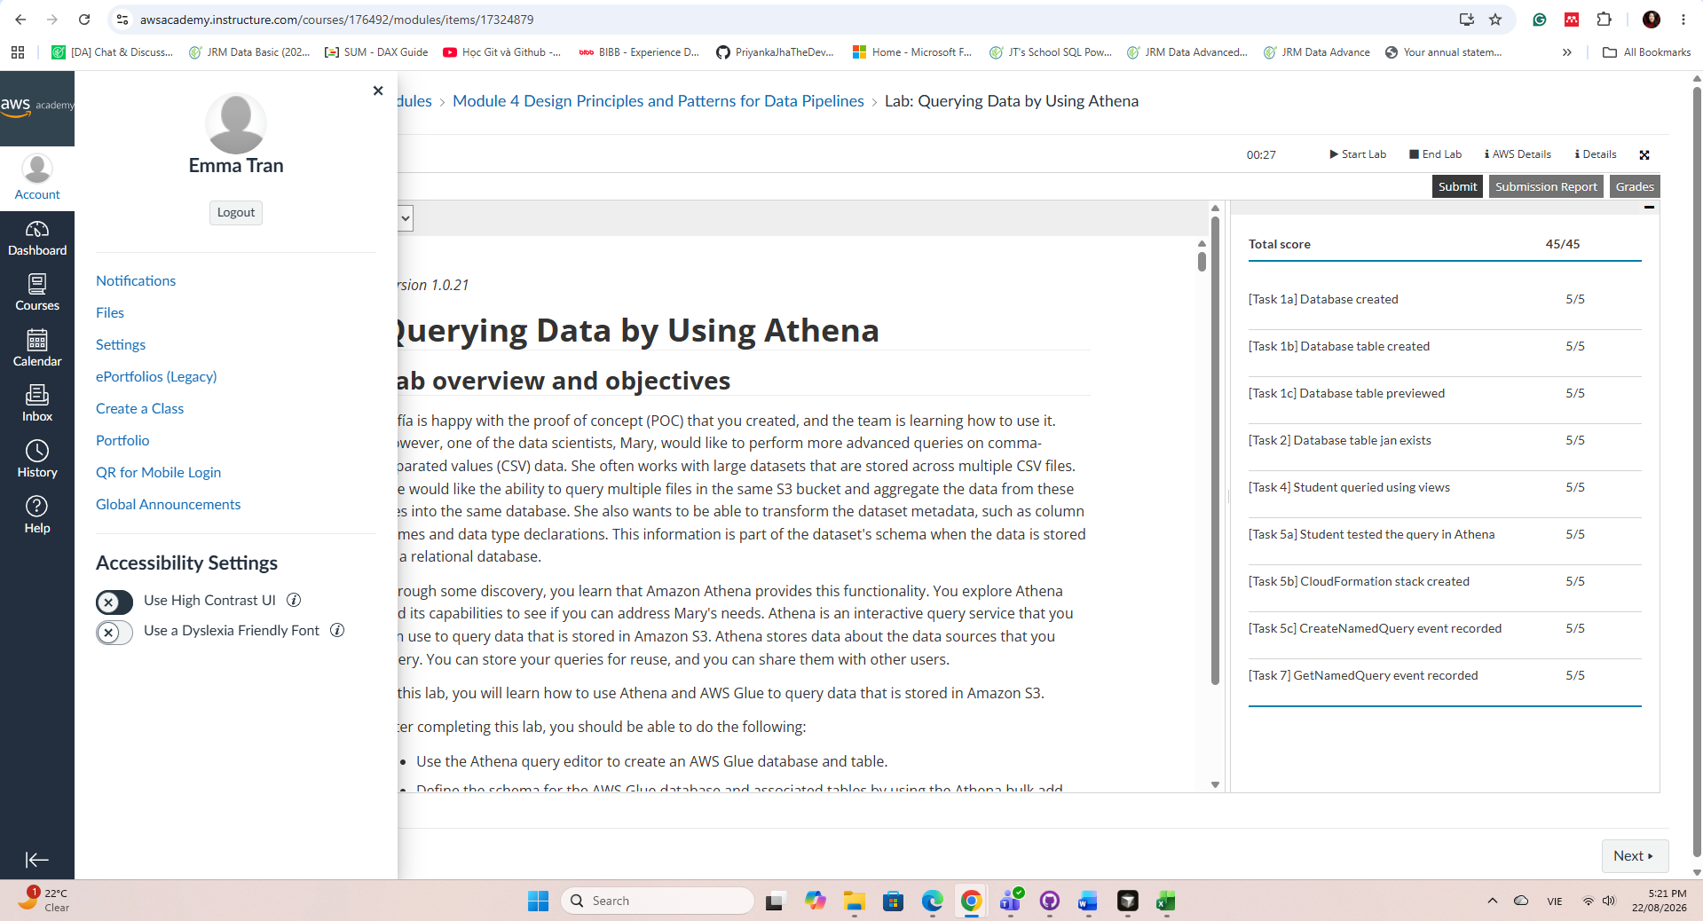
      - Individual Project Contribution
https://github.com/HendrickDang/PRT661-DATA-SCIENCE-PRACTICE/commits?author=EmmaTran56

      - Brief Professional Reflection

            - Student Information
Name: Ngoc Anh Nguyen (Will)
Student ID:
            - Laboratory Completion Evidence of:
Laboratory 1 – Lab: Querying Data by Using Athena (Module 4)

            - Individual Project Contribution

            - Brief Professional Reflection

- Student Information
Name: Van Hoi Dang (Hendrick)
Student ID: S395598
Role: Analytics and Machine Learning
- Laboratory Completion Evidence of:
Laboratory 1 – Lab: Querying Data by Using Athena (Module 4)
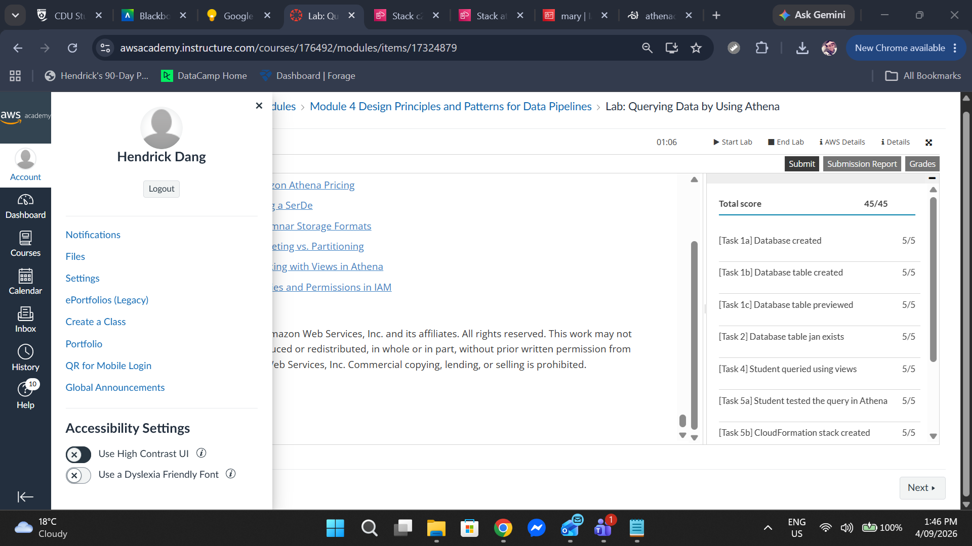
- Individual Project Contribution
My contribution since Assessment 1 has focused on the analytics and evaluation stage of the pipeline, responding to the Assessment 1 feedback on the modelling plan.
+ Designed and implemented evaluation.py, a standalone forecast evaluation module providing naive baselines, leakage-free feature selection, rolling-origin backtesting at four horizons, empirical prediction intervals and structural-break indicators.
+ Identified and corrected two sources of information leakage in the existing pipeline: feature-variant selection performed on the held-out test set, and feature scaling fitted before the cross-validation split.
+ Established seasonal naive and twelve-month moving average benchmarks, and produced the comparative accuracy table reported in Section 3.
+ Defined the forecast task specification, drift thresholds and retraining rules, and clarified the incremental-learning stage that the Assessment 1 feedback questioned.
+ Authored the Analytics and Machine Learning subsection of this report, and the risk analysis and ethics sections of the Assessment 1 report.

- Brief Professional Reflection
The most useful lesson from this stage was that a model comparison is only meaningful against a benchmark. The Assessment 1 report compared several regression models against one another and presented the winner as a result, but without a naive baseline there was no way to tell whether any of them added value. Once a twelve-month moving average was introduced, it outperformed every fitted model at every horizon. Reporting that honestly was more uncomfortable than reporting a favourable result, but it is the more defensible position and it changes what the team should build next.
The second lesson concerned information leakage. Both instances I found were subtle and produced plausible-looking output, which is precisely why they were easy to miss: selecting a feature set on the test set and scaling before splitting both improve reported accuracy without improving actual forecasting ability. This has changed how I approach validation. I now treat the question of what the model was allowed to see, and when, as the first thing to establish rather than a detail to check at the end.

            - Student Information
Name: Le Nhat Minh Tran (Thomas)
Student ID: S390789
            - Laboratory Completion Evidence of:
Laboratory 1 – Lab: Querying Data by Using Athena (Module 4)
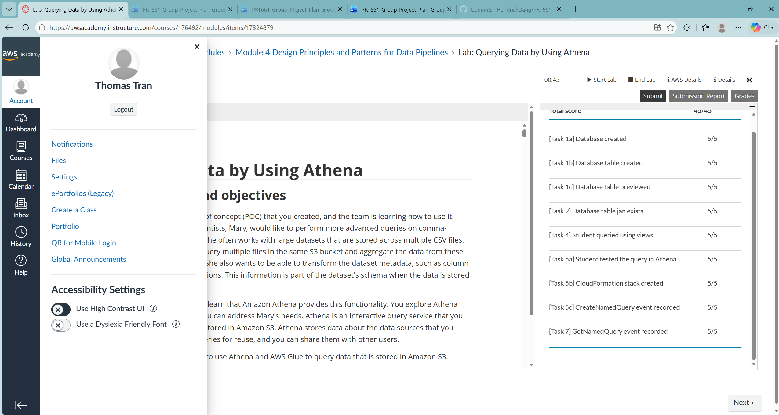
            - Individual Project Contribution
In this assessment, I maintain multiple roles, mostly with the technical side of the project. My contribution includes:
- Review the output from the ingesting and preprocessing steps, doing basic testing to see if anomalies exist and also seeking clarification when necessary, making sure that the processed data are ready for the next steps
- Researching and choosing appropriate machine learning models and techniques from wide range of options and implementing them in the pipeline
- Documenting and writing up reports based on my findings

            - Brief Professional Reflection

Throughout this assessment, I primarily contributed to the technical aspects of the project, which enabled me to further develop my analytical, research, and problem-solving skills. Working on the project significantly enhanced my understanding of machine learning models, model selection processes, and performance optimisation techniques. Evaluating different approaches and implementing suitable solutions provided valuable practical experience in applying machine learning concepts to a real-world problem.
In addition, conducting extensive research to identify evidence and theoretical foundations that supported our findings exposed me to a wide range of important concepts and contemporary developments in machine learning. This experience not only deepened my technical knowledge but also broadened my appreciation of the academic research that underpins data science and predictive analytics.
Another key lesson gained from this project was the importance of collaboration and communication. Through regular communication with teammates and tutors, I developed a better understanding of how projects are managed in professional IT environments. Participating in discussions, sharing progress updates, and seeking feedback helped me appreciate the value of teamwork, stakeholder engagement, and effective project coordination in achieving successful outcomes.
Overall, this project strengthened both my technical expertise and professional skills. It reinforced the importance of data quality, evidence-based decision-making, continuous learning, and collaborative teamwork when developing reliable and impactful data-driven solutions.

